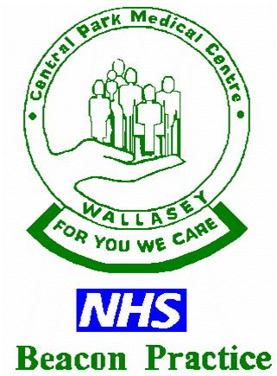

Central Park Medical Centre

Certificates
- Private sick note/Medical Certificate £40.00
- Simple photograph counter signature £40.00
- Private prescription for drugs not needed immediately
by patients travelling abroad £40.00
- Course of vaccinations for travel abroad
(per course + vaccine costs) £50.00
- Vaccination certificate £40.00
- Freedom from infection £40.00
- Holiday cancellation Insurance Claim form £45.00
- Fitness to travel £45.00
- Fit to attend gym membership £50.00
- Firearms renewal £65.00
- Child Minding OFSTED report
(patient can claim fee once established child minder) £110.00

Reports
- Provident association claim form (e.g. BUPA) £50.00
- School fees insurance claim form £50.00
- Sickness / accident insurance benefit claim form £45.00
- Sickness / accident short certificate without examination £35.00
- Character reference £50.00
- Brief GP statement / extract from records/Support letters £35.00
- Medical report and opinion without examination £85.00
- Medical report and opinion with examination (ie: Taxi/HGV meds) £170.00
- Copying medical records electronic / Lloyd George notes
£10.00 + 50p/page up to max of £ 50.00
- iGPR £ 75.00 / £104

Medical examinations
- Pre-employment Medical Examination with Report £170.00
- HGV / PSV / Taxi Driver medical with full Medical £170.00
- Elderly driver fitness Certificate with full Medical £170.00
- Racing driver / Pilot / Sports fitness with full Medical £170.00
- Power of Attorney Certificate only / Examination and Certificate £ 50.00 / £95.00
- Fit to attend School Report only / Examination and Report £ 65.00 / £85.00
- Seatbelt exemption Examination and Report £170.00

Revised July 2025

