Wirral MIG/HIE
Integrated Privacy Notice

You have told us you don’t want to have to tell your story every time you see a different doctor, nurse, visit hospital or A&E; this can be stressful and takes a long time.
The reason you’ve had to do this up until now is because every health care organisation holds a different set of records about you.
The Wirral MIG/HIE Project will enable us to bring together your information and present this to the professional caring for you, but only once they have your permission and if your GP practice have agreed to enable this.

How it works
The Wirral MIG/HIE Project securely connects Wirral GP Practices and Wirral University Teaching Hospital’s computer systems together.

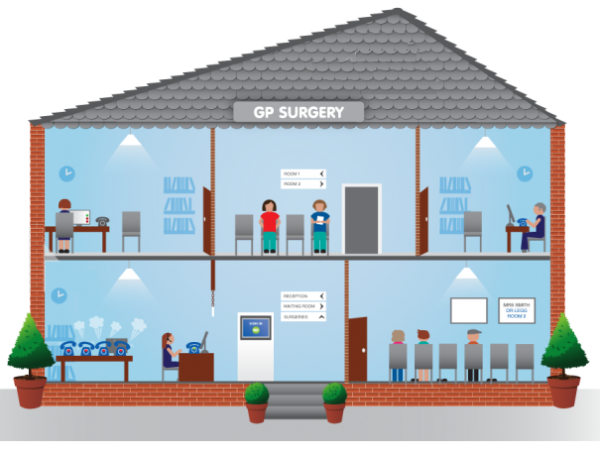

When your records are requested, it collects the information from the different systems and shows the information to the requestor. None of the information it collects is stored and none of it can be changed. Because it collects the information only when it is needed, the information is always accurate and as up to date as possible.
Before any information is collected or displayed to a care professional, that professional must have your consent to view your record. Your consent is recorded on the system so that we know exactly who has accessed what information and when.

The Wirral MIG/HIE Project uses the secure NHS network to retrieve the information and displays a read only view for the care professional to use to support the delivery of care at that specific point in time.

What information will be shared?
The sharing will allow:

GP Practices to see the following information from Wirral University Teaching Hospital:

- Visits
- Future Appointments
- Laboratory Results
- Radiology Results
- Microbiology Results
- Discharge Summaries
- Medications
- Allergies
- Diagnoses
- Procedures
- Immunisations
- Vital Signs

Wirral University Teaching Hospital to see the following information from GP Practices:

- Patient Details
- Summary View including current problems, current medication, allergies and recent tests
- Problem view
- Diagnosis view
- Medications including current, past and relevant issues
- Risk and Warnings
- Procedures
- Investigations
- Examinations (Blood pressure only)
- Events consisting of visits, admissions and referrals

Certain types of “highly sensitive” information will be restricted from sharing under this agreement.

Who is involved?

- NHS Wirral Clinical Commissioning Group GP practices that have signed up to the Information Sharing Agreement and opted to enable information sharing
- Neston Medical Centre/Neston Surgery (members of West Cheshire Clinical Commissioning Group)
- Willaston Surgery (members of West Cheshire Clinical Commissioning Group/part of Bridgewater Community Healthcare NHS Trust)
- Wirral University Teaching Hospital NHS Foundation Trust

Wirral Clinical Commissioning Group is encouraging all Wirral GP practices to take part. The more patient records that are shared in this way, the more likely your care provider will find the information needed to provide you with better quality and more effective care.

Not all care providers can view the shared information. It is only available to the care organisations in Wirral that have signed up to the Information Sharing Agreement.

Can I refuse to allow my records to be shared?
If you are concerned about sharing your GP and Hospital records you can opt out of allowing them to be shared. If you do not wish for your information to be shared, then please contact your GP practice who will arrange this. This can be done at any time – now or in the future.

What will happen when healthcare professionals want to view my record?
You will be asked directly to give your explicit consent, at the point of contact, for your record to be viewed. You can say “yes” or “no”; the consultant/Doctor will only view your record if you say yes.

You will be asked beforehand for permission by the assessing healthcare professional each time your record is viewed. The healthcare professional is only viewing your record; they are not downloading, amending or storing any of your data. This means that when they close your record it is no longer accessible.

If you are unable to give consent, for example if you are unconscious and it is deemed vital, then a healthcare professional may view your record in order to be able to provide appropriate care for you. In this situation, the healthcare professional must state a reason consent has not been obtained (e.g. patient is unconscious), this is logged in the system and is fully auditable.

For Further Information
Please see our leaflet

For further information you can discuss the sharing of your records with your GP.

